**Endeavour tips**

->To check for changes in the code do **‘F %’**

**Retrieve elements and signout**

**En;3(Batch)**

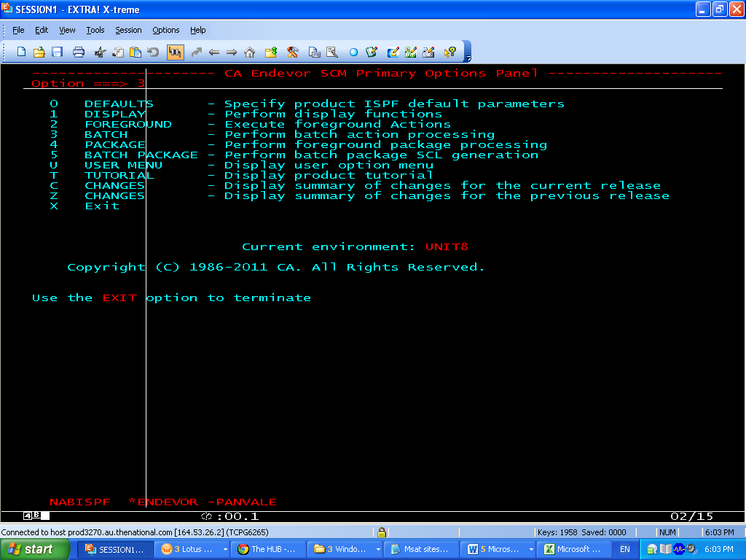

**3(BUILD SCL)**

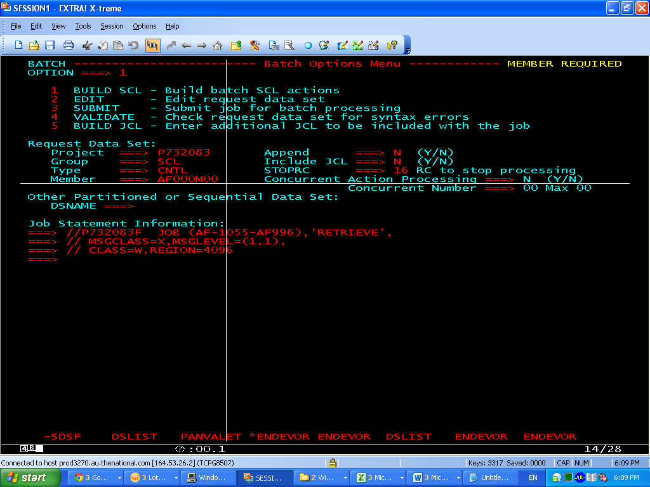

//P732083F JOB (AF-1055-AF996),'RETRIEVE',

// MSGCLASS=X,MSGLEVEL=(1,1),

// CLASS=W,REGION=4096

**3(RETRIEVE)**

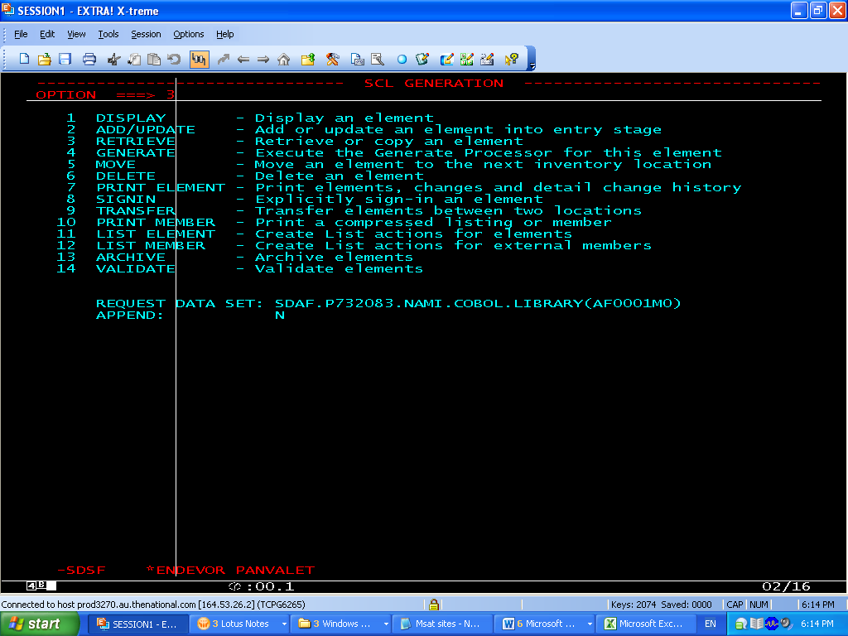

**GIVE**

**SIGNOUT ELEMENT ===> N**

**DATA SET NAME ===> 'SDAF.P732083.NAMI.PANV.COBOL.LIBRARY'**

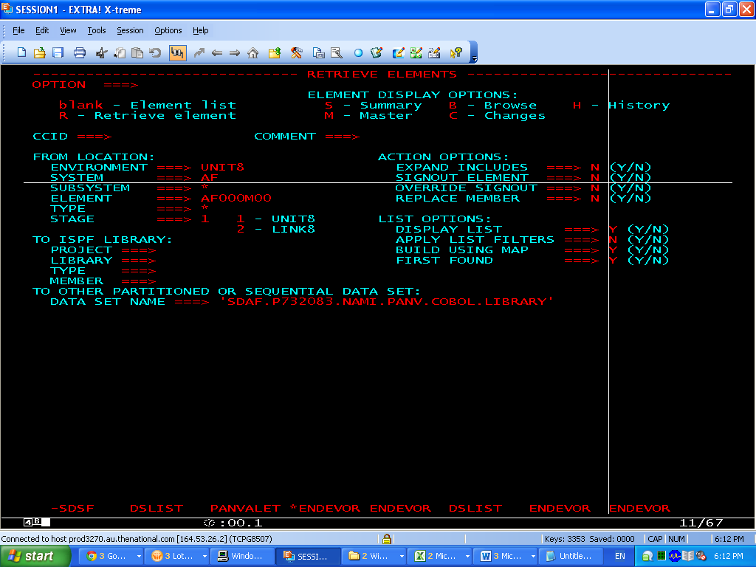

pRESS f3 TWICE AND finally submit the jcl by selecting **3(SUBMIT)**

